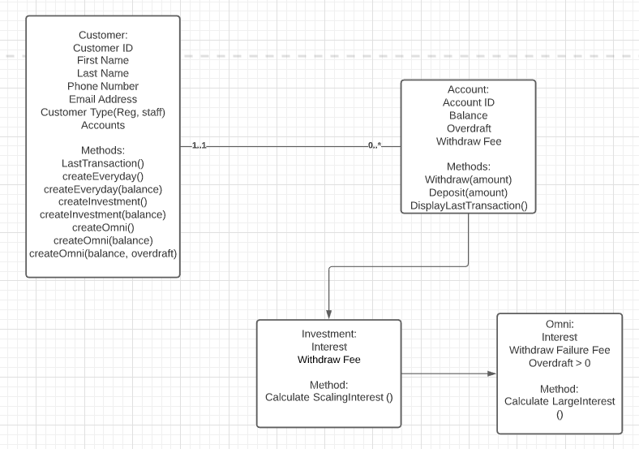

There isn’t an awful lot of classes to be made for this project, I have chosen to have the Account class represent the Everyday Account as specified in the assignment as it holds the bare bones of what an account needs to have, withdrawal and deposit functions, no interest, overdraft or fees. The investment and omni account classes inherit the base functionality from the account class and add in the required functionality of their additional requirements. Originally, I was considering having staff be a child class of customer however I deemed it pointless as it wouldn’t need more than an extra variable to function the way its intended.

Assuming there were no additional fees, functions or features Investment accounts became children classes of Account (everyday) and Omni became a child account of Investment as to share the setup of additional variables.

I added a Display Balance button, a Check interest button and a clear log button to help the user read and understand what was being done at what time.  
  
For demo purposes there have been 2 Customers created: 1 being a regular customer and the other being staff, each with 1 of all the account types. Customer creation is not available through the UI for this assignment.

Github link : https://github.com/deHewett/bankProject